NZMC Notes – Issue No 33 May / June 2018

Hello all,

Welcome to the third edition of NZMC Notes 2018:

The Voice of Our Musical Director:
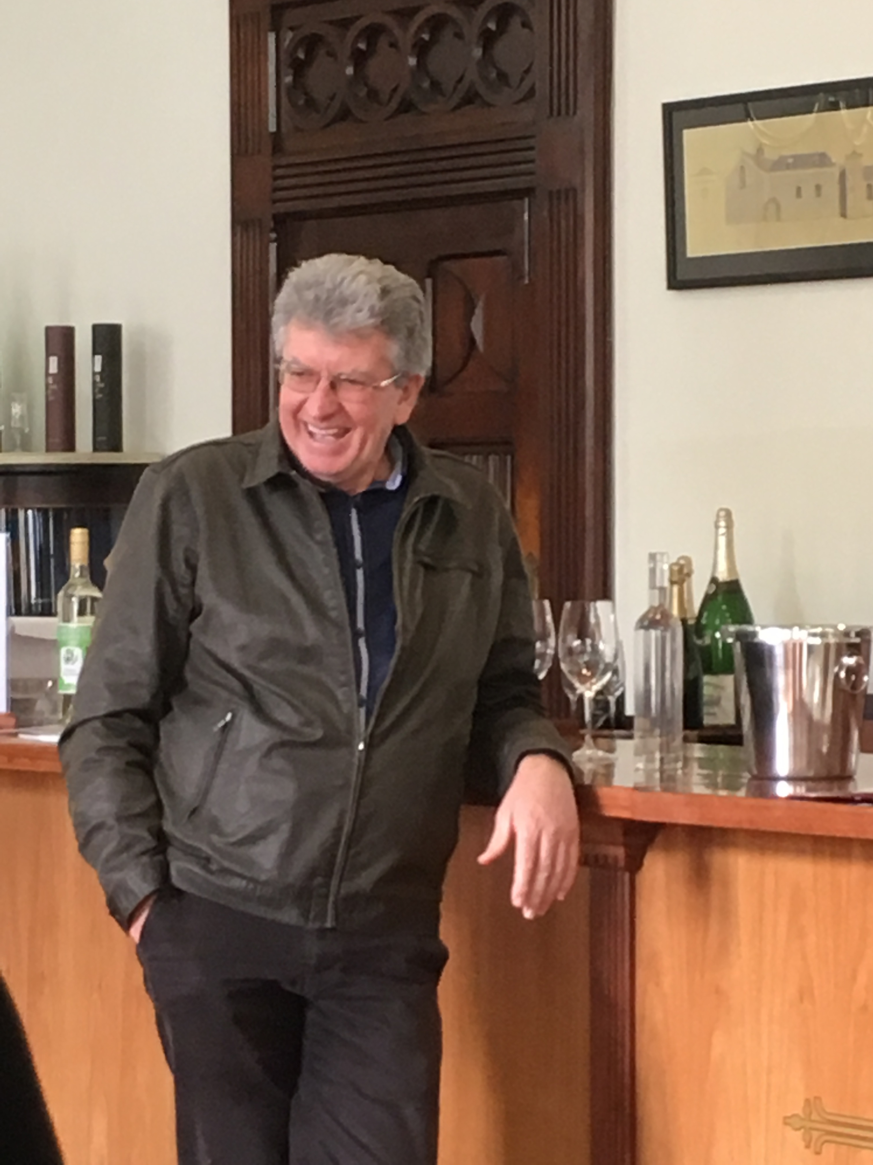
“I think it is safe to say the tour was a success. While the shopping, the shady tours and the afterglows may be foremost in some memories, for me the music was great.
The choir coped with awkward stage configurations, getting on and off stage in various ways, standing for far too long in the first concert, the whole range of different acoustics and a grumpy MD (but that is normal).
We also got to hear Alex play more notes than are humanly possible at one time in the Sydney combined concert (what a fantastic performance) and to hear Rebecca Crabtree, (what a lovely voice), she must come and sing the Easter hymn with us.
Working with other choirs and conductors is always intriguing and I enjoyed the opportunity to watch and learn. We had 3 very different choirs to work with but the enjoyment of singing was evident in all of them.
Thank you to Alex for being such a great support, to Dick for doing such a sterling job of keeping the troops in line, to Gordon for informing the audience and to everyone who worked to make sure I could focus on the music.
Well done. When do we do it again?” Joe

The Treasurer and President Maurie write:
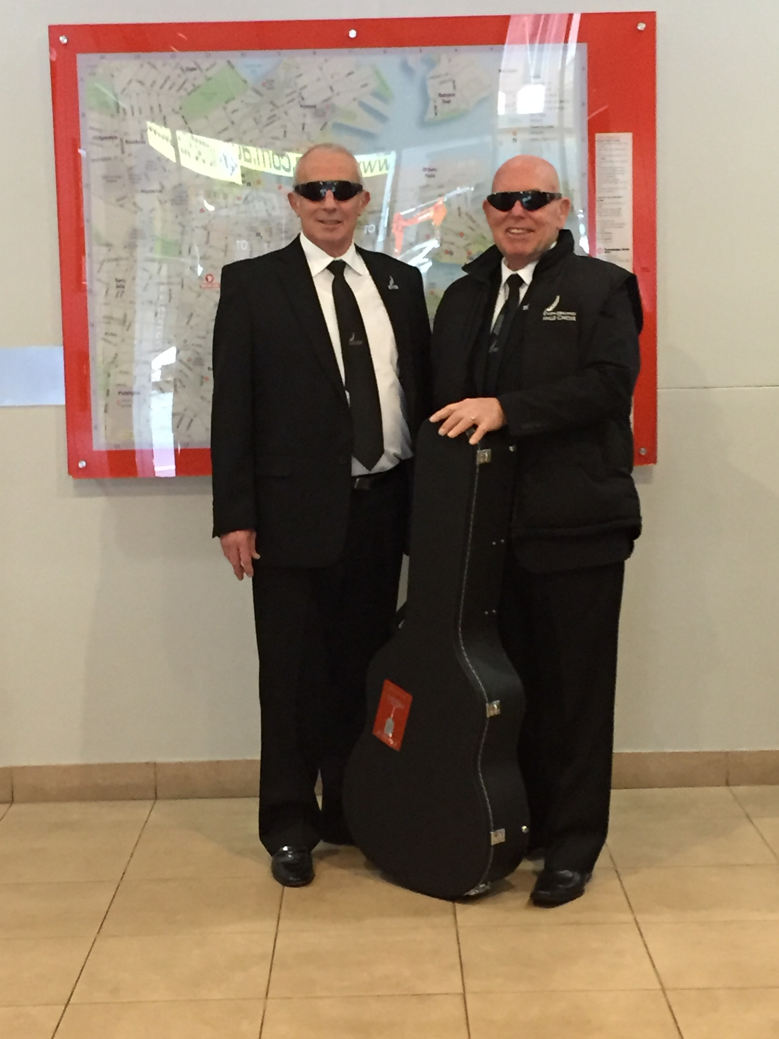
“A successful tour! We expect to receive some $ as proceeds from concerts in Wagga Wagga and Adelaide where there were very good attendances. Not so sure about Sydney where audiences less than expected. Waiting to hear on all accounts.
Whilst Sydney not great attendances.... It is clearly not all about numbers when via our web site we received an email [see below].” Warwyck
…and from Maurie: “What an amazing tour. We were greeted with outstanding hospitality and warmth wherever we went. Wagga Wagga ‘s generosity in hospitality with billeting was exceptional and a full house for the concert! I am certain that everyone was impressed with the beautiful sound! We even impressed Joe. In Adelaide we were greeted with a large LED display board at a major intersection advertising NZ Male Choir. Another full concert in the stunning Bonython Hall was a wonderful finale to the Tour.
Men in Black
Thank you to all our choir family.” Maurie

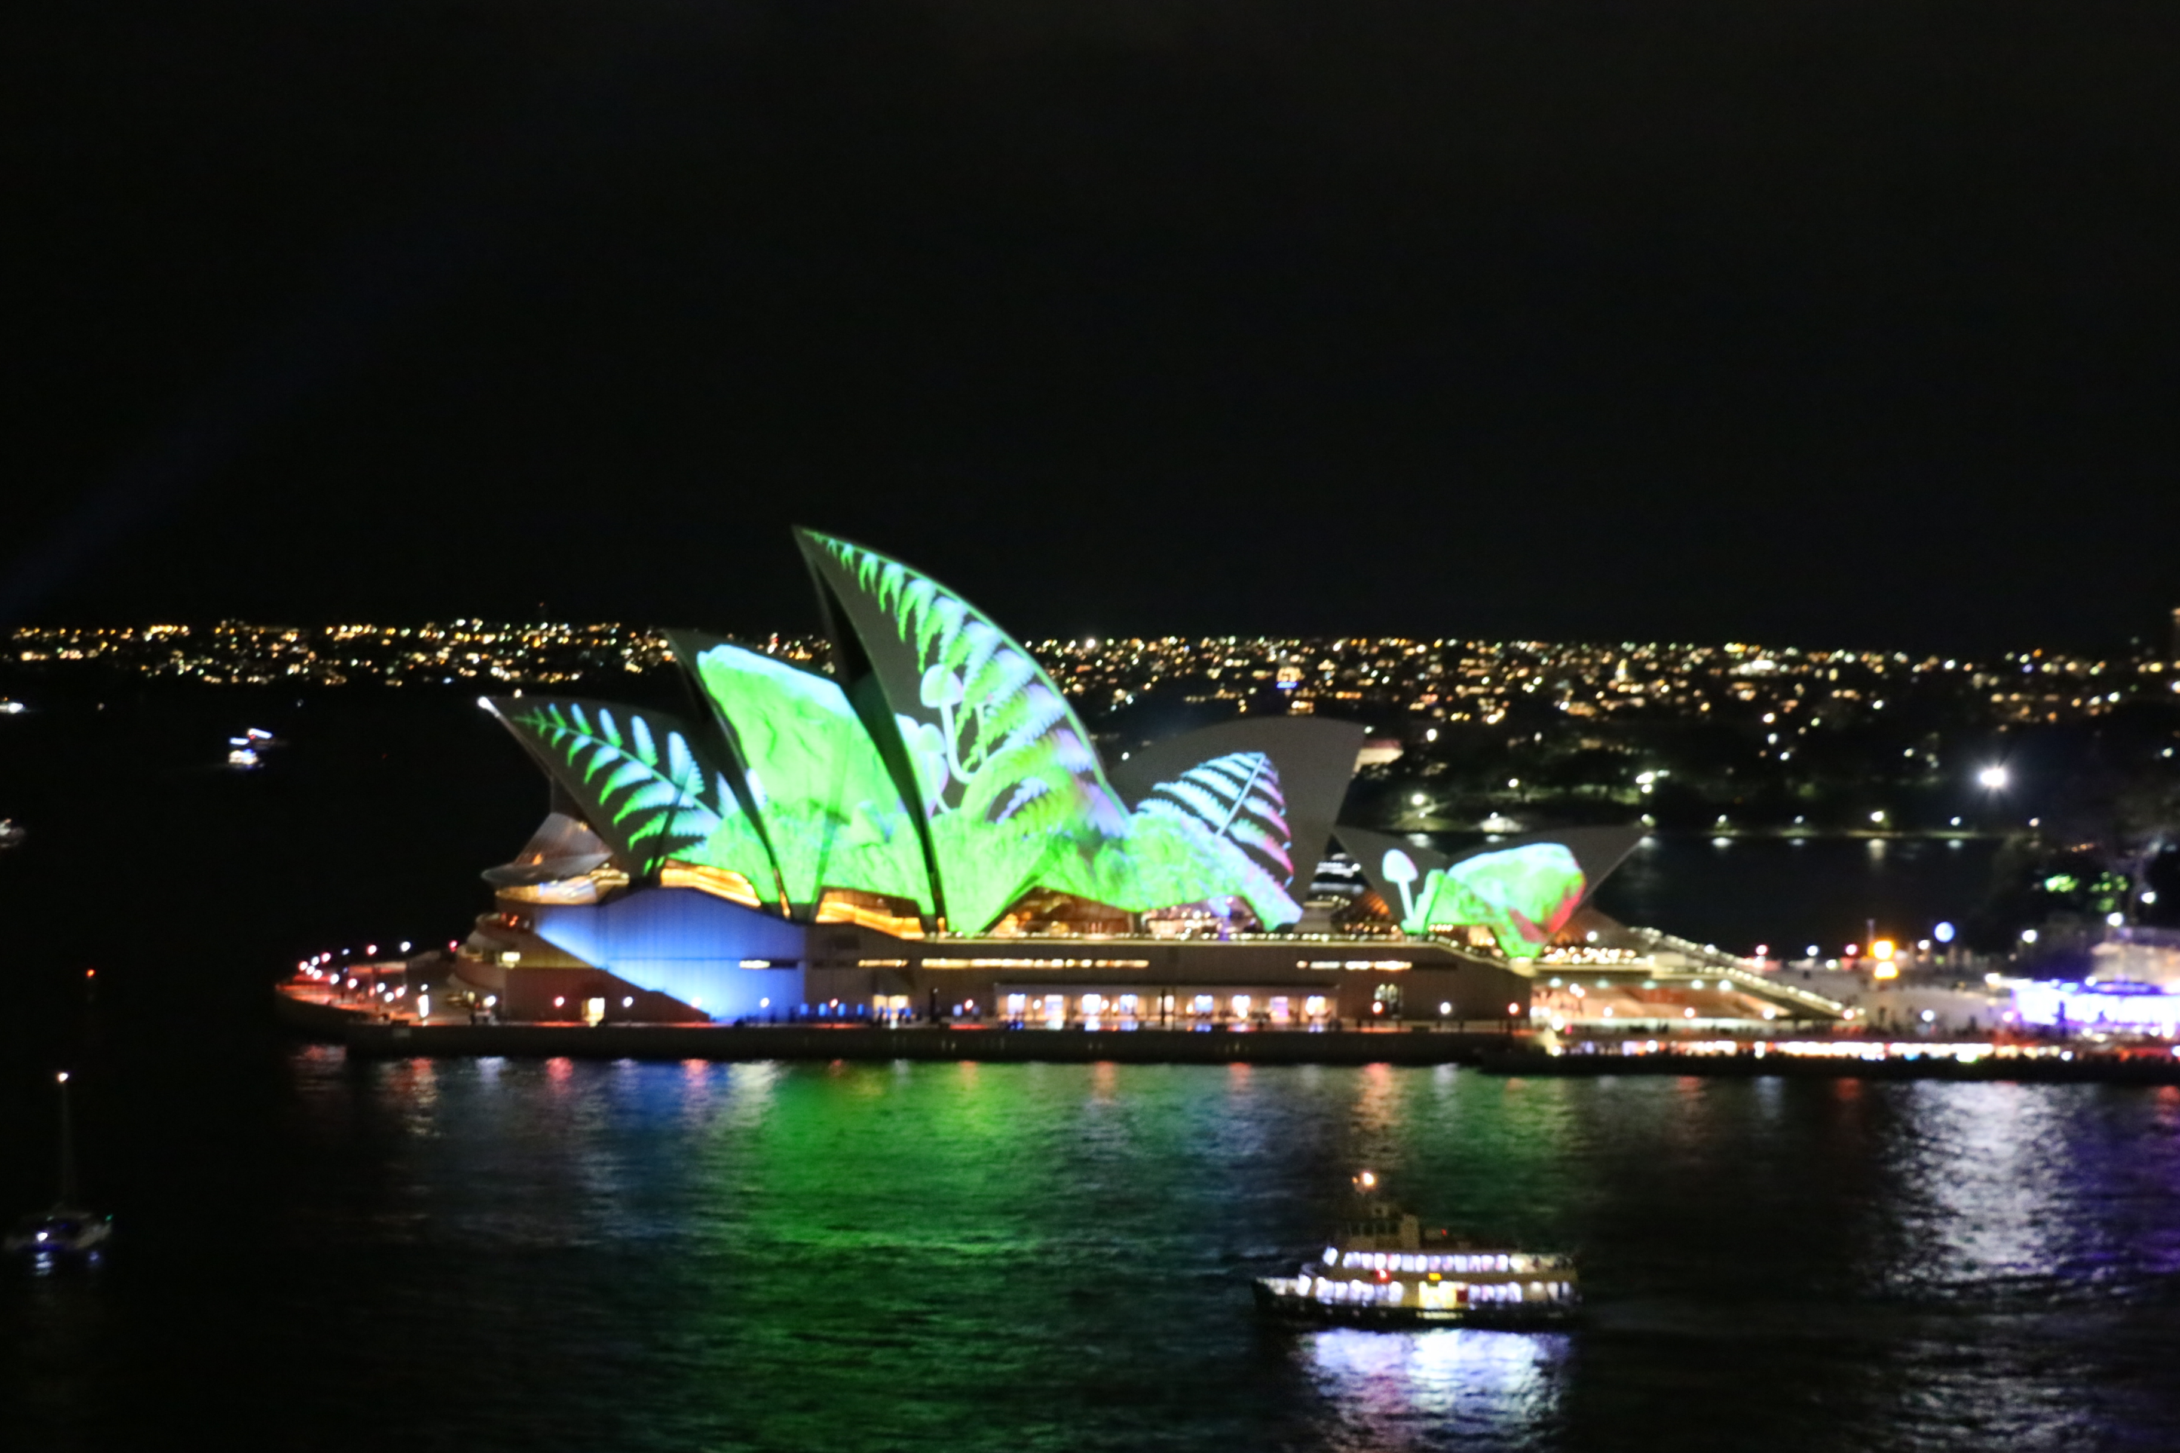
Hello
As part of a team of paxing Air NZ cabin crew, I noted members of your choir traveling alongside us on our flight to Sydney last Thursday 31 May.
Coincidentally, the following day I was walking past St Stephen's Church in St James and saw the wee advertisement for your performance. Thank you for a most enjoyable hour of culture, humour and entertainment. It was definitely something out of left-field for me, but it left me with a lovely warm feeling of national pride ... what a lovely way to spend a wet winter's afternoon.
Trust the remainder of your Australian tour went just as well.
Kind regards
Sally Palmer
Air NZ Midhaul Cabin Crew
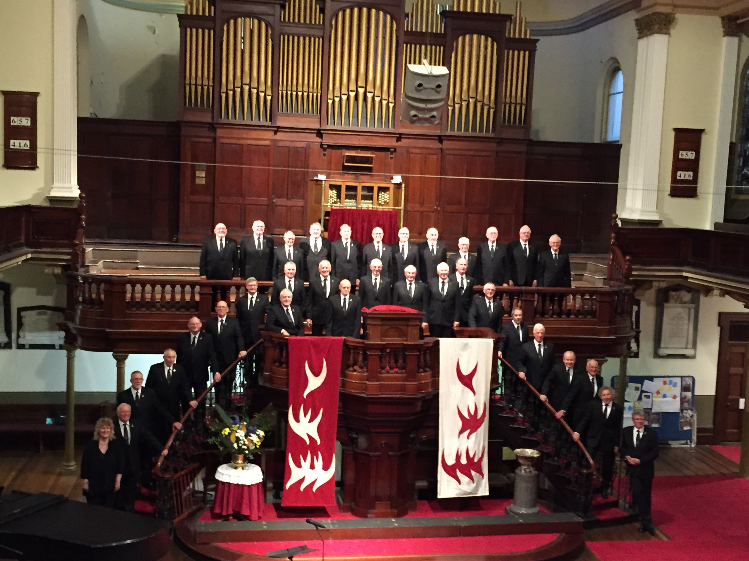
NZMC St Stephen’s, Sydney

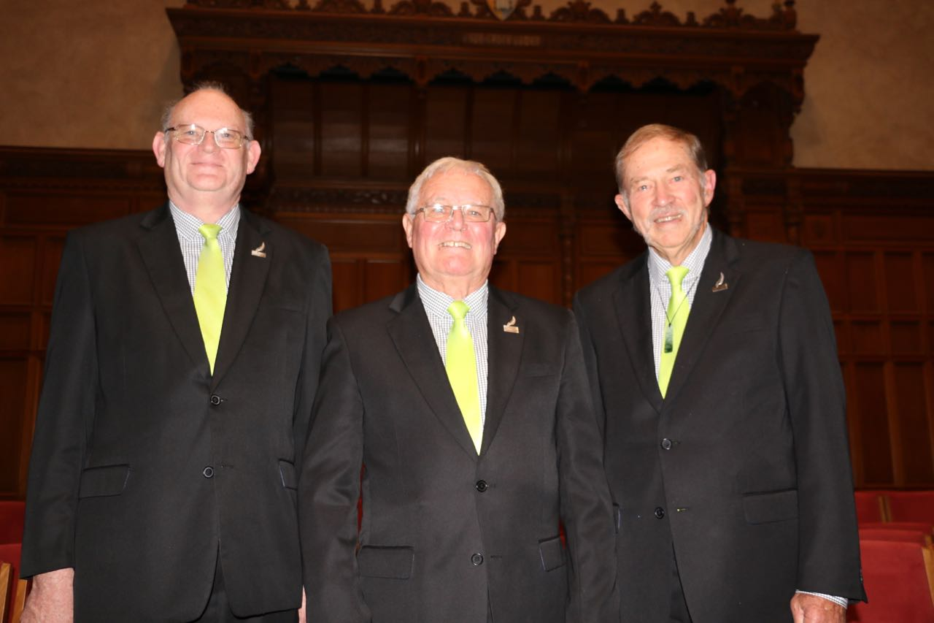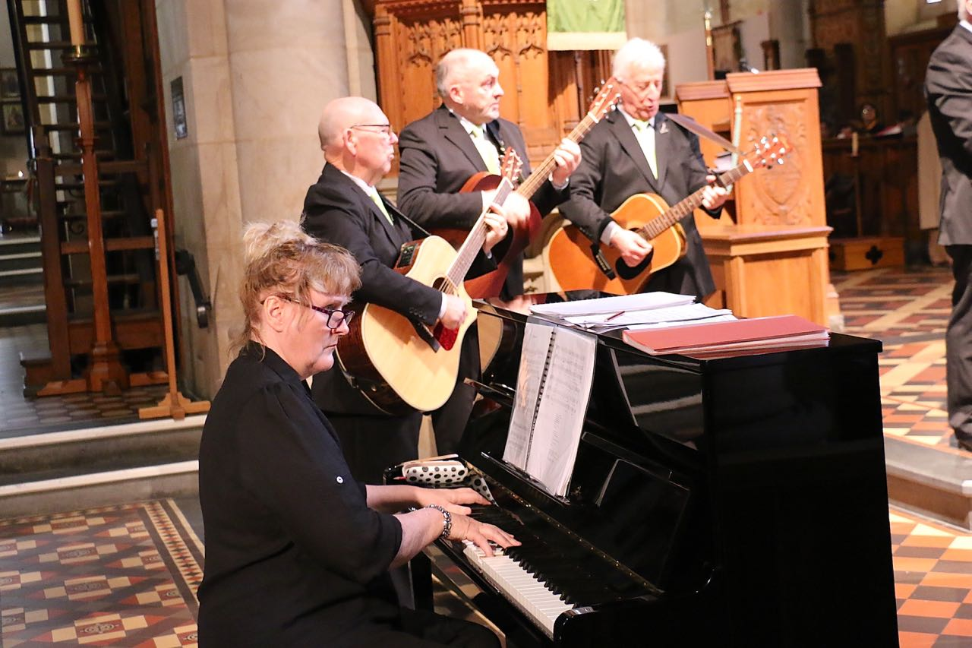

Ian Doel, Taffy Davies, Tony Clemow Alex with Maurie, Norman and Oliver.
“The Incorrigibles”

Sydney to Wagga Group Check In – ‘Smooth As’!!
Follow up from The Charity Concert in Taupo:

Jenny Brown writes…”Hope you and the choir had a good tour in Australia recently.
It would be great if you could include these two short videos of Megan walking; before and after her operation. The op went well and she’s now doing the hard yards with physio etc, to improve on the ‘after’ video!!!
Great news for her and her family and everyone who helped with the process!!!!”
Cheers, Jenny

Megan’s Before Operation Video Link
Megan’s After Operation Video Link

Farewell to a Foundation Member: Arch Barclay tribute from Tony Clemow

Archetype

Arch Barclay was archetypical: a unique and engaging ‘dinkum’ character. An Old Contemptible, a relic from the millennial tour of Wales in 2000, Arch had a laconic wit and a withering propensity for word play. After all he had been a reporter for the Nelson Daily Mail. I became aware of this when perusing the reports of the Murchison Earthquake during a campervan journey in 2013. His poignant prose captured the desolation of a community in extremity. He himself was a man of extremes who lived life to the extreme.

Regrettably this was my last encounter with this singular man. However, I have many memories of Arch the performer and Arch the orchestrator. Chief of these was our collusion in an in-house concert at Fairwater College in Cardiff in July 2000. This was in honour of the staff who had catered for our needs during a period of considerable travail. About 50% of our number were ravaged with a dreadful bacillus which had its worst manifestations in the communal latrines. At this concert Arch distinguished himself by performance and by his mastery of the compere’s role. The show (not the flow!) was videoed and is the only record of ‘unofficial entertainment’ enjoyed on our numerous trips at home and abroad. The few copies still in existence are truly treasures for the record.

Arch also starred as a vocal artist in between the brackets of massed voices. His Tevye renditions were sheer magic and had schoolgirls pressing for autographs during intermissions.

His tobacco emissions were another story. How did the old bugger live so long? It must have been sheer cussedness. It was not in his DNA to miss a trick.

Poem to Archetype

John Botting
Vice President
NZMC

