

**2024 EUROPEAN TOUR**

**4th June 2024 - 26th June 2024**

**NEWSLETTER No. 3**

**COMPREHENSIVE TRAVEL INSURANCE**

It is important tour members now take out full comprehensive travel insurance policies. You may purchase this through World Travellers or through your own preferred travel agent or broker.

Costs for such cover do vary between providers but it is imperative everyone obtains appropriate levels of cover - and especially so for those with “pre-existing conditions”. There are countless horror stories out there of people who suffered severe financial hardship because of travelling overseas uninsured and even under-insured. The *medical benefits cover is a must* for anyone travelling overseas.

Some may wish to access Travel Insurance offered by Credit Card companies. If using this option, please be very careful to ensure the cover provided is appropriate for your needs. Look at the terms and conditions carefully, especially any age limitation, as well as the abovementioned “pre-existing conditions.

Remember the old maxim of “comparing apples with apples”. If you have any doubts or questions, contact your agent or insurance company.

**PHYSICAL FITNESS**

You will know from the tour outline and the concert schedule, we have a very demanding three week tour. We could well be doing in excess of ten concerts and some of these, particularly at the Alta Pusteria Festival, may well be at non-traditional venues. Physical fitness will be essential, more than ever, for this tour.

Haunold Hutte (pictured) is one such non-traditional venue. It is an alpine ski lodge at 1,500m above sea level and is accessed by chair lift. Clearly one needs to be both confident and mobile to safely mount and dismount from the chair lift to get to Haunold Hutte. Zimmer frames aren’t of any help here!

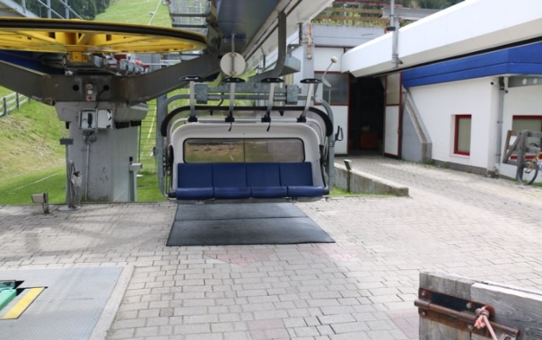 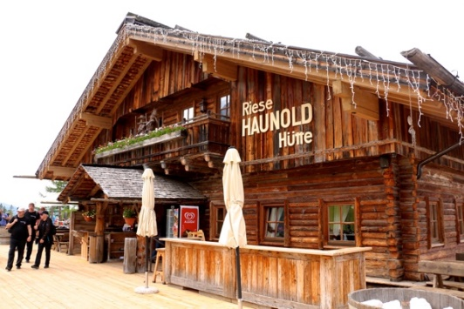

**CHORISTERS**

It is vital everyone is available for every performance. In order do this effectively you will need to have good levels of both physical and vocal fitness. Whilst Joe can assist with your vocal fitness ***YOU*** have to take personal responsibility for physical fitness. You can’t “get fit by watching”!

**CHORISTERS, PARTNERS AND SUPPORTERS**

In addition to participating in the concert programme, there will be a good deal of walking on tour. Some of that will involve walking up and down steps and stairs as well as walking on uneven surfaces such as cobblestones. To enjoy the experiences, you will need to be fit.

Walking is a good start - 10-15 minutes building up to 40 minutes. Power walking using your arms and pumping is a good add on. Walking up and down stairs is another excellent exercise. How many can you do in 10 minutes?

*Note:* if you are having trouble or experiencing pain, consult your doctor who will be able to advise you.

There are numerous exercise programmes you can follow. There is always the option of attending regular gym sessions. ***Doing nothing is not an option!***

Physical fitness is one of the key goals you should be setting for yourself in preparing for this tour. Below are two links to websites giving advice on fitness for those intending to travel. There are many other such websites that are only a Google-search away. Please avail yourself of this advice.

[**https://wwwnc.cdc.gov/travel/page/senior-citizens**](https://wwwnc.cdc.gov/travel/page/senior-citizens)

[**https://www.racgp.org.au/getattachment/584e19e7-d3b6-400b-b034-09e25071aa35/attachment.aspx**](https://www.racgp.org.au/getattachment/584e19e7-d3b6-400b-b034-09e25071aa35/attachment.aspx)

**We urge you to carefully consider your own physical well-being and fitness before committing to the tour. You cannot put added responsibility on other members of the Tour party.**

**LASTLY, A THOUGHT FOR THE DAY:**

