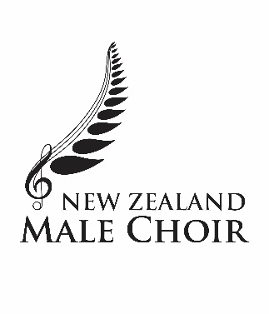

**NEW ZEALAND MALE CHOIR EUROPEAN TOUR CASUAL SHIRTS**

As part of the tour package, choristers and supporters will each be issued with two shirts - black and white - embroidered with just the NZ Male Choir logo. The men will have short sleeve only, but the women can have the option of short sleeve, ¾ sleeve or long sleeve. There is no charge for these.

It is recommended choristers purchase a second black shirt at own cost, bearing in mind the frequency of performances at Alta Pusteria and therefore the need to have a fresh shirt for the next performance. Cost NZ$52.30 incl. The purchase of extra shirts is optional for everyone – both choristers and supporters.

For the women, four samples in ¾ sleeve and different sizes will be at Art Deco for viewing.

**MONACO SHIRT**

Taking its cue from European shirt trends for design details, the Monaco provides extra flair to a classic all-rounder shirt. Made with stretch cotton blend fabric, this is Biz Collection’s most versatile shirt yet.

**FABRIC**

68% Cotton, 28% Polyester, 4% Elastane

• Built in stretch. • UPF 30+

**FEATURES**

**Mens** style features modern collar, chest pocket, twin back pleats and adjustable cuff, curved hem – can be worn in or out. Short sleeve.

**Womens** style features french style Y-neckline and turn up cuff design, with waist and bust darts, longer length with curved hem – can be worn in or out.

Option of short sleeve, ¾ sleeve or long sleeve.

**GARMENT MEASUREMENTS.**

**MENS CLASSIC FIT** xs S M L XL 2XL 3XL 4XL 5XL

Garment ½ Chest [cm] 52.5 55 57.5 60 63 66 70 74 84

**WOMENS SEMI-FITTED** 6 8 10 12 14 16 18 20 22

Garment ½ Chest [cm] 45.5 48 50.5 53 55.5 58 61.5 64 66.5

Measurements are approximate and are for reference only. Note ½ half-chest measurement.

Images of the shirts can be viewed on the following links.

**Men:**       <https://www.fashionbiz.co.nz/product/biz-collection/s770ms>

**Women:** <https://www.fashionbiz.co.nz/product/biz-collection/s770lt>

**The Choir requires any clothing worn on tour bears only the current logo, as above.**

This is also the opportunity to order a replacement jersey with the current logo.