 **2024 EUROPEAN TOUR**

**4th June 2024 - 26th June 2024**

**NEWSLETTER No. 8**

Firstly, thanks to everyone for a wonderful time at the Art Deco weekend. Particular thanks to all of our friends from over in the Bay for their organising, their work and their hospitality which went into making the weekend so enjoyable. It was also great to be able to meet some of the newer members of our tour party and to put faces to names. We hope that you folks also enjoyed your time there.

We are now barely three months out from departure on Tuesday 4 June 2024. I know already a number of people in our tour party are beginning to make preparations for the trip – especially given the majority of the party will be journeying on after the Tour concludes.

Listed below are a few (hopefully helpful) tips which may aid you in your preparations, together with a few reminders.

**Travel Baggage**

Here’s some things to think about when selecting (or buying new) travel luggage. **Remember that automated baggage handling systems are notoriously rough on luggage.**

* What size do I need? Medium-Sized” cases are typically about 70 cm long. They are fine for carrying say 14 – 18 kg. “Larger- Sized” cases are typically about 80 cm long. What do you need? Most on the Tour could get by with a “Medium”. Choristers may need a “Large” because they will be carrying a Choir Uniform.
* Hard Shell or Fabric? – Hard Shell are robust, but of fixed volume. Fabric are expandable, but susceptible to rips. I prefer Fabric, but it’s a personal choice. Buy what works for you.
* **Quality of wheels** – look for really robust wheels (how well would they travel over cobblestones?). Four wheeled “Spinners” are great on flat level surfaces, are easy to push, but are not good on inclines (may run away!) or on rough surfaces. Select wheels that are well protected. One regularly sees broken (flimsy) wheels in the vicinity of airport baggage carousels, courtesy of the automated systems.
* **Weight** can be a real problem. It’s all too easy to overfill a suitcase. Don’t take 23 kg because you can. Take 17–18 kg because that’s all you need! I’ve done two overseas trips of 2–3 weeks recently with 17 kg and that was plenty. (Washing Powder is very light! Consider taking a “braided” washing line with suction cups?).
* A wise person once suggested that you should pack your bag 4 weeks out - and then go through it 1 week out and **remove half of it!**
* Quality of zips – these need to be really robust. Look for big, strong (plastic?) teeth.
* Adequate external pockets – with robust zips. internal ones big enough for A4 files.
* Buy suitcases that can be “piggy- backed”. (See photo example below.) **These allow for one free hand to use on handrails, elevators and the like.** Highly recommended for “elderly persons”! Again, another good reason for selecting robust wheels.

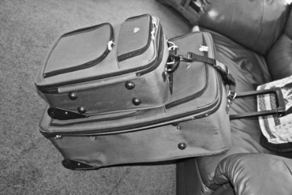 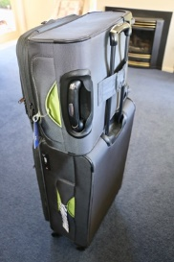

Two examples of cases being “piggy-backed”

* Luggage Strap – Buy one that’s robust and brightly coloured. Secure one of these around the midriff of the main case. It helps take the load off the zips - and makes your case easier to spot.
* Coloured Identification Label. Helps prevent you (or someone else) picking up the wrong case off the carousel. You’d be surprised at how many dark green Flylite cases may be found on the belt at any one time.
* Use a Cable Tie to “lock” the main suitcase zips – 150 mm x 3.2 mm ones work well. (Bunnings or SuperCheap Auto). But you will need to carry a cheap pocket-knife in one of the outside pockets of that case to cut the tie off at destination. No problem with the pocket-knife because this bag goes in the hold. I’ve used this system for years without incident. Forget padlocks and keys!
* Can you Carry It? – **Are you able to pick up your loaded case with one hand?** If not, take some stuff out. There may well be situations where you will have to lift that case up some steps (ramps are not everywhere) or perhaps up some stairs.  **Don’t assume there will be a fast or large or functioning elevator** at every place you’re going to – especially so for those going off on post-tour extensions.
* Last thought: Consider putting into your case a light two-strap Backpack. This to carry your items for one day out, such as a water bottle, sunglasses, sunhat, sunscreen, camera(?), light rain jacket, small folding brolly(?) and the like. Having two straps makes it more difficult for a cyclist with a craft knife to steal. (Single strap handbags may be vulnerable in that regard.) **But even more importantly it leaves you once again with two hands free!** Think **stability.**

**Flight Socks (Compression Stockings) and DVT**

There is evidence that periods of **immobility**, such as occurs on long-haul flights (5 hours plus), may cause or contribute to Deep Vein Thrombosis (DVT). The risk is generally low, but not zero.

To reduce the in-flight risk, include stretching, moving one’s legs regularly, walking occasionally and keeping well hydrated. Also, wearing below-knee Compression Stockings may assist preventing DVT. They are quite readily available and cost about $35 - 45 per pair.

Here are two links to websites which can provide further information on DVT:

[**https://medsafe.govt.nz/profs/PUarticles/travthromb.htm**](https://medsafe.govt.nz/profs/PUarticles/travthromb.htm)

[**https://www.sehd.scot.nhs.uk/publications/DVTAirTravel.pdf**](https://www.sehd.scot.nhs.uk/publications/DVTAirTravel.pdf)

It could be wise to talk with your GP if you are concerned about the possibility of developing DVT.

**Keith Carey-Smith adds**: The main point to note is the importance of advice from a GP for those at particular risk (not just the age risk!). Some may be prescribed low dose aspirin or some other anticoagulant if considered to be a particular thrombosis risk. This applies also to those who have had recent lower body major surgery.

Keith Suggests (perhaps tongue in cheek?) “We all need to stand up in the plane at intervals, and walk around down the aisles singing He Honore!”

**New “Computed Tomography” Airport Scanning Machines**

During the Reconnaissance last year, Oliver and I found many overseas airports had installed the new Computed Tomography baggage scanners. Christchurch and Wellington are to get them shortly.

[**https://www.rnz.co.nz/news/national/507142/new-scanning-technology-introduced-at-wellington-christchurch-airports**](https://www.rnz.co.nz/news/national/507142/new-scanning-technology-introduced-at-wellington-christchurch-airports)

The use of these scanners eliminates the need to take items such as laptops or power cables, together with liquids, aerosols or gels, out from your case and place them in those huge clunky plastic trays. Now you just pass the whole bag – computer and all – straight though. Much easier and less stressful.

**Power Adapters**

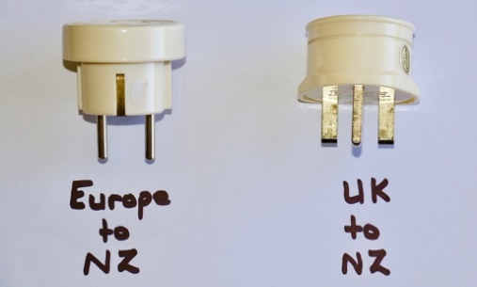If you wish to use NZ electrical appliances in either Europe or the UK you will need to have a Power Adapter. Here is an image of our two. Note the European one has two pins where the UK one has three.

I believe you can actually put a 2 pin European plug into a 13A UK socket, without an adapter, but have never tried it.

If you have multiple devices (phones, cameras, shavers and the like) that you may wish to charge all at once, consider taking a 4-outlet Multi-box with you, Then you need only one adapter, not four.

**Baggage Trackers (Apple AirTag)**

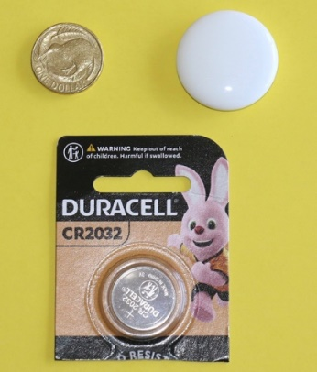I bought one of these Apple AirTags before we went on the Reconnaissance in June. It cost $59 from Noel Leeming. (Currently selling for $49.) They’re not much bigger than a $1 coin.

Just activate the battery, then pair it up with your iPhone. Place it somewhere in your suitcase and away it goes. (No problem with airport x-ray scanners either.)

Locate it using the “Find My” app on the phone – and the accuracy is truly astonishing.

It runs on CR2032 Button Batteries – readily available and cheap as chips. The battery lasts about 14 days on continuous running, but would last much longer if you took the battery out when not required.

I’m sure there must be an Android equivalent.

**Medical Assistance Overseas**

You may be aware New Zealand has reciprocal health agreements with Australia and the UK. Under each, certain services may be publicly funded for people covered by these agreements. However, there is no such agreement with European countries. This means that those seeking medical assistance in Europe will be expected to pay – and possibly to pay up-front. (This is where one’s Travel Insurance kicks in).

Yours truly experienced this in Vienna some years ago, suffering from dehydration. An up-front charge of €150 was levied at the ED Reception desk and a Passport needed to be sighted. Fortunately, Joc was carrying hers that day and it was deemed to be sufficient. Whew. Fortunately the €150 (less excess) was reimbursed by the Insurance Company on our return to NZ.

**Medications**

Each of us needs to ensure we are carrying sufficient medications for the entire duration of the trip – as a minimum. **Remember: Delays Do Occur!** Consider putting a few tablets (in their original containers of course) in your cabin bag just in case your suitcase is delayed or lost.

Talk with your GP if you think you may need to access supplementary medications whilst away. It is tricky, but it can be done. You might also like to think about asking for a script for a few sleeping tablets as it’s not always easy to sleep on an aircraft.

If you think you may be susceptible to particular infections (Urinary Track - maybe?), then do ask your GP about a strategy to deal with this.

**Debit Cards, Credit Cards and Travel Cards**

Regardless of the information below, make sure you advise your bank you will be overseas. Our banks in New Zealand will block any transactions on your debit /credit card made, from overseas transaction points, unless you advise them of your travel arrangements.

There are numerous ways to access cash and to make payments when overseas. Some of these are:

* Credit Cards
* Debit Cards
* Cash
* Travel Cards

I am not an expert on the Foreign Exchange system, but know enough to understand that every such FX system has its pros and cons. It seems to me when choosing a system to use there are certain key considerations one should check, including:

* Which method of payment will I use when overseas?
* How do I convert NZ currency to an overseas currency?
* Can I make cash withdrawals if I need cash? How hard/easy it that?
* What fees will I incur in making payments or cash withdrawals overseas?
* If I put money onto a debit card or travel card, how secure is it?
* What happens if I lose my card overseas?
* Is a digital card better (harder to lose?) than a physical one? Should I take both??
* How secure are “contactless payments”, such as those made using ApplePay or GooglePay?

**WISE Card**

The WISE card is a relatively new product from a company based in the UK.

It is a debit card (available in both digital and plastic forms) onto which you can load NZ currency. When overseas, that currency can then be used for purchases or withdrawals through ATM’s in over 40 countries. And the big advantage of WISE is their very low “Overseas Currency Conversion Fees” when compared with other bank cards. (For popular currencies such as **AUD, GBP, USD and EUR, you'll pay around 0.35%.)**

Additionally, when making overseas transactions, the currency conversion is done at the time of transaction, so the rate used is the actual current FX rate.

Fiona McCabe [NZMC pianist] has been using a WISE card for some time now. On her recommendation, I’ve gone ahead and signed up for one. The on-line process is relatively straight-forward and once completed, the Digital WISE card gets stored in your “Wallet” on an iPhone and links easily from there to ApplePay. (I’m sure Android phones will have similar facilities.) I’ve also taken up the option of getting a hard-copy (plastic) card as well.

We are going to Australia soon and so I’m looking forward to taking it and trialling it over there. Watch this space!

Here are Fiona’s views on WISE:

*“It was very easy to set the account up and had good security. It is also very easy to transfer money in and out of the account, and between approved people.*

*WISE has a one off joining fee otherwise there are no hidden costs and very low exchange rates compared with other cards.*

*I was able to take out the equivalent of NZ$350 cash per month from an ATM at no charge but I didn't really need cash as most countries are now contactless after COVID. I used the digital wallet on my phone to pay for many things but there is also the option of a physical card.*

*I have the WISE app on my mobile and it is very user friendly, and has a ton of information about how the account works.*

*WISE has multiple currencies so I was able to pay using local money wherever I was, and again could easily set this up from my phone app. I found it easy to track what I was spending because I could also choose to pay using NZ$ and WISE would show the current exchange rate. “*

If you are thinking of getting WISE do some research checks first, using reputable NZ agencies. But in the end, choose whichever card or FX method will work for you.

**Domestic Flight Bookings**

I would hope that by now most of us have either made our domestic flight bookings or at least are in the process of doing so.

For those flying out of Christchurch, please be aware Singapore Airlines flight SQ298 departs at 10:50am on Tuesday 4 June 2024. Check in time at 8.20am, if not before. Be aware, Christchurch Airport sometimes suffers from fog early in the mornings at this time of year. It can be a real problem for those coming in on turbo-prop aircraft. For peace of mind, we are recommending those coming into Christchurch do so a day or two early. Perhaps look to arrive on Monday 3 June or earlier? Those departing from Christchurch would need to be at the Christchurch International Terminal by about 08:20am at the latest.

For those departing from Auckland, your Singapore Airlines flight SQ286 departs at 14:10hrs (2.10pm) in the afternoon on the same day. You will need to be at Auckland International by 11:40am, if not before. Likewise, consider going to Auckland the day before to avoid possible flight delays due to adverse winter weather conditions and fog. Indeed, some of us have already done so.

Both flights are direct to Singapore’s Changi Airport.

**Passport Expiry Date**

Please check this once again. The expiry date needs to be **at least six months** beyond your anticipated date of return into NZ.

**Lastly, Some “what if’s” To Think About.**

What might you do in the following (unlikely) situations:

* Your main case doesn’t arrive, or arrives late?
* You lose your Cabin Bag?
* You lose your Passport. How do you get a replacement? What’s the cost? - and how long does it take?
* Your Purse or Wallet gets stolen.
* You lose your VISA Card? How do you cancel the card when overseas? And how do you get a replacement? How long does that take? Cost??
* You need additional Prescription Medicines when overseas?

**Finally, a Little Light-Hearted Humour.**

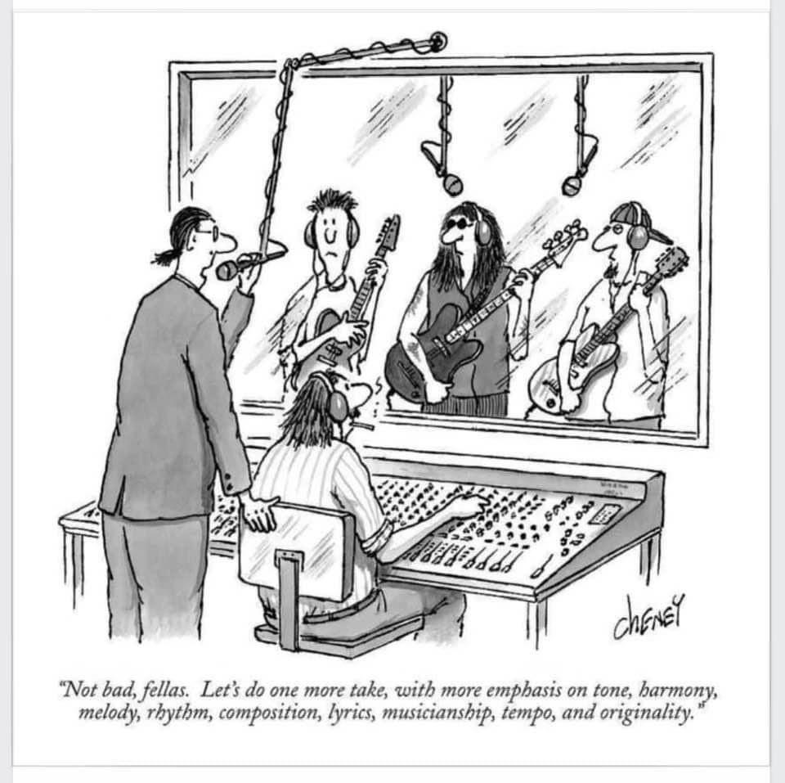

Kind regards

**Ian Gabites**

**Tour Convenor – New Zealand Male Choir**

**Tel: 06 753 2989 Mob: 021209 3787**

**Email: iandjgabites@xtra.co.nz**