

NZMC Friends Newsletter – March 2024

Kia ora all, on behalf of the Management Committee, we are pleased to provide this quarterly edition of our NZMC Friend’s Newsletter.

We have had a great start to the year with a successful and enjoyable Hawkes Bay Art Deco weekend and our Europe trip plans are developing nicely.

**Our 2024 Programme**

For your information here is the program for the next six months and we would love to see you when we are in your area. Also, if you can recommend anyone to join us, they are very welcome to join any of our rehearsal weekends to meet us. More detailed information is available on our website (<http://nationalmalechoir.co.nz>) or contact our secretary [secretary@nzmalechoir.co.nz](mailto:secretary@nzmalechoir.co.nz) .

|  |  |
| --- | --- |
| **Concerts** | **Rehearsals** |
| Whanganui – 13 April 2024  Italy Tour- 3 June-25 June  Te Aroha – 3&4 August | Morrinsville – 9-10 March |
| Christchurch 23-24 March |
| Christchurch 27-28 April |
| Whanganui 11-12 May |
| Christchurch 24-25 August ( TBC) |

**Art Deco Weekend**

We had a wonderful time in Art Deco with two concerts over the weekend. The first was in Havelock North where we performed with mixed ensembles from the Havelock North Highschool, a very talented group of students. The second was in Napier Waiapu Cathedral along with Octavius and soloist Cindy O’Sullivan. This was a very enjoyable concert enhanced by our guests and enjoyed very much by a good audience.

**Farewell to a loyal and dedicated Choir member**

Many of you will know Tony Clemow one of our most dedicated and poetic choristers who retired from the choir over the Art Deco weekend. Tony was a foundation member joining the then "National Male Choir of New Zealand" in 1999. Since then, he has participated in over 150 concerts both domestically and internationally. Over this time Tony has also shared his talent for the pen, writing numerous and amusing poems of the exploits of the choir which he culminated in his book that traced the choir history through his poetry.

We wish Tony well for his future and thank him for his valued contributions to the success and fellowship of the choir.

Tony was presented with a long-service award and the choir sung He Honore is his honour.

And see the bottom of the newsletter where Tony has the last words…

**New Zealand Male Choir Facebook**

We have set up a new public Facebook site for Choir. The purpose is to add to the profile  of the choir, promote our events and attract new members.

You are very welcome to join as members/followers of the site. Please "like" the site and send it to your friends and family to spread its following and exposure.

Follow this link:

<https://www.facebook.com/profile.php?id=61555926935109>

We would love to hear from you so if anyone has any photos or items of interest they wish to share please contact Anthony Joines [ajoines63@gmail.com](mailto:ajoines63@gmail.com) who is currently managing the site.

**Membership**

We have quietened our membership drive due to the upcoming tour but managed to gain one new member who has rejoined the choir and is coming on tour, we welcome Keith Spooner from Hamilton.

Unfortunately, have had the recent resignation from Norm Phipps from Nelson. Farewell Norm and we thank you for your friendship and dedication.

**Choir Family**

It was good to see our choir family members Brian Barrett, and Warwyck and Royce Dewe at the Art deco weekend. We also had a great gathering at Joe and Vonda’s country retreat where we shared a lovely brunch and a relaxing time after the hectic rush of Art Deco.

**Commissioned Work**

We have had the fortune of a commissioned song from Fergus Byett an up-and-coming New Zealand Composer.

Fergus is a pianist and composer based in Hamilton. He completed his Bachelor of Music with First-Class Honours in 2022 , and his Masters in Piano Performance in 2023. As a teen he won the New Zealand Choral Federation and SOUNZ Choral Composition Competition, he is a previous winner of the University of Waikato Chamber Music Competition, a finalist in the University of Waikato Concerto Competition and he was a Sir Edmund Hillary Scholar for the duration of his undergraduate studies.

Commission by us Fergus has written and composed “Te Aotearoa ( The Long White Cloud)” for debut in our 2024 European tour. It’s a beautiful waiata telling the story of the discovery of New Zealand.

We are very fortunate to have worked with such a talented young man and look forward to performing this lovely piece both nationally and internationality.

**We would still love to hear from you !!**

We welcome contact with all past choir family members. We would love to hear how you are going and invite you to our concerts or practices when we are in your region. Please make contact and update us on your contact details as well so we can keep in touch.

**Choir Contacts**

Jen Brown – Secretary Email: [secretary@nzmalechoir.co.nz](mailto:secretary@nzmalechoir.co.nz) ph. 027 446 8436

Ray Seymour - President Email: [ray.seymour@xtra.co.nz](mailto:ray.seymour@xtra.co.nz) ph. 027 447 5379

Anthony Joines- Vice President Email: [ajoines63@gmail.com](mailto:ajoines63@gmail.com) ph. 027 273 4035

Kind regards to you all and hopefully we will see some of you as we venture around the country.

Ray Seymour

President New Zealand Male Choir

Te Roopu Waiata Tira Tane O Aotearoa

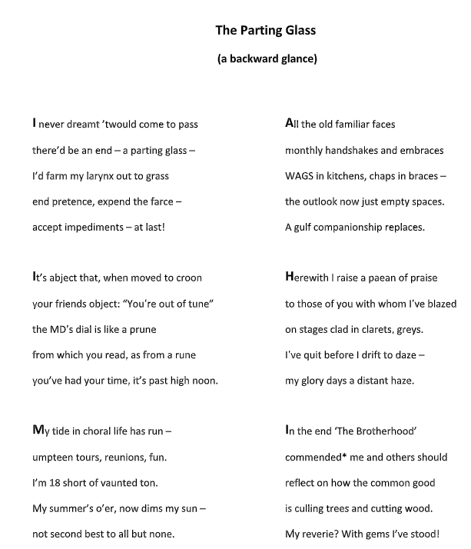

Tony Clemows Farewell