 **2024 EUROPEAN TOUR**

**4th June 2024 - 26th June 2024**

**NEWSLETTER No.12**

**‘War & Peace’**

Good afternoon everyone. It’s now less than three weeks before we depart and whilst much has been accomplished to date, there still remains much to do. Apologies in advance for the amount of information that follows.

**World Travellers**

It was great to have Silvana Gottini attend the Rehearsal in Whanganui on Sunday morning and for many to be able to put a face to the name. The company has done a great job in getting all our travel and accommodation requirements completed in such a friendly and efficient manner.

By now, everyone should have received their travel wallet from World Travellers which should include an Itinerary, Insurance Policy (for those who booked with WT) including Train Tickets and Accommodation Vouchers for those travelling on. Silvana advised that the Singapore Airlines ticket(s) will be an eTicket and will be emailed out once the seating has been confirmed – possibly within the next ten days.

Please contact Silvana or Steph directly (Tel: 03 528 1550) if something is not correct.

Additionally, by now everyone should have received their new Biz Collection tour shirts. Thanks Oliver, for organising this distribution. They look good.

**Domestic and International Flights**

Please be sure to arrive early for all flights – including Domestic. The Bag-Drop time is ***critical*** and is rigorously enforced these days – and your bag cannot fly without you accompanying it!

International Departures have already been communicated. WT advise arriving three hours before an international departure.

**SQ298 departs CHC at 10:50am. Need to at CHC International by 07:50am.**

**SQ286 departs AKL at 2.10pm. Need to be at AKL International by 11:10am.**

**Bank**

Advise your bank that you are going overseas.

Perhaps consider doing a small VISA transaction on Departure and again on Arrival back in NZ to confirm your actual dates overseas. This may help avoid scamming on a VISA Account or possibly alert the bank to anything suspicious.

Also remember that Tax Returns are due by 7 July for those to whom this is applicable.

**Winter Energy Payments**

Again, for those to whom it applies, please be aware that Winter Energy Payments are made from 1 May to 1 October. If you are overseas for more than 28 days during this time, your payment may be affected. Please get in touch with the Office of Seniors regarding this.

See [Overseas travel dates for NZ Super or Veteran’s Pension](https://govt.us7.list-manage.com/track/click?u=08037fd157f2dd5ab02092f5c&id=1ed31e0941&e=46db7e9b51)or call 0800 552 002.

Refer to Office for Seniors April Newsletter, 02/04/24.

**Medications**

Here is advice from Dr Jim Montgomery (one of our travelling GP’s) on taking medications overseas:

“Prescribed medicines may be taken overseas as long as the medication is in the proper packaging with the patient’s name and prescriber’s name on it. A letter from the prescriber is a bonus, but probably not necessary.”

**Medical Assistance Overseas**

If the unthinkable happens and you have to seek medical assistance overseas (such as at a hospital A&E department) you will most probably need to furnish a Passport for ID and pay an Initial Charge, usually by VISA, before receiving any treatment.

For my little dehydration episode at Vienna Hospital some years ago I was fortunate that Joc had her Passport with her (deemed as sufficient ID) and a charge of €250 was levied up front.

**Passport Expiry Date**

Please check this once again. Your Passport needs to have an expiry date on it which is at least six months beyond your scheduled date for arrival back into NZ. As already mentioned, “The Unthinkable Does Occasionally Happen”! Think accident, illness, or emergency here.

**Update on WISE**

I took the opportunity to try out the WISE card on a recent trip to Australia. Here are a few observations:

1. The card is a Debit Card, not a Credit Card. Funds need to be loaded on the card before making transactions.
2. Use the WISE App to transfer funds to the card from any NZ bank account. Easy to do. Very similar to doing a Funds Transfer in On-line banking. Each upload costs $NZ2.36 irrespective of the amount uploaded.
3. I prefer the Digital Card on my phone. The Card is Passcode (PIN) protected.
4. Both cards (Digital and Physical) worked flawlessly.
5. The fee charged was a flat 0.45% each time.
6. The exchange rate varied from 0.914 – 0.918. About 0.2c better than ANZ was offering.
7. Every transaction is logged in a detailed way. A pdf receipt can be printed out from the app.

Overall, I’m very impressed. It will certainly be going to Europe.

**Baggage Allowances**

Recent advice from our travel Agents World Travellers indicates anyone travelling in Economy on Singapore Airlines may take **two** bags on their flight(s), as well as a 7 kg Cabin Bag. **But** the **combined mass** of the two checked bags must not exceed 30 kg. (Remember the checked bags go in the aircraft hold.)

Those travelling in Premium Economy and in Business have slightly more generous allowances (35 kg and 40 kg respectively).

Also, **large luggage items** may be declared “oversize” by the airline. To find out if it’s oversize you need to measure its Length, Width and Height. The sum of these three dimensions needs to be less than 158cm (A + B + C = 158 cm). An industry-wide standard.

But those travelling on AirNZ domestic flights are normally limited to **one** checked bag of **23 kg.**  However, AirNZ will also allow a passenger to take an **additional bag** on domestic flights - provided one **adds this** to an **already-purchased** ticket.  The cost for the “Prepaid Extra Bag” is $35 per sector and the mass limit is 23 kg. This is a good option for anyone going out on or coming off a Singapore Airlines flight with two bags.

**Using Mobiles Overseas**

You are probably aware that using your phone overseas can be expensive. NZ providers (OneNZ or Spark) charge you a flat NZ$8.00 per day for what’s called Data Roaming. Two months continuous Roaming could amount to $500. Apparently one can switch Mobile Data on and off. But does the “day” begin at 00:00 hrs NZT or at 00:00 hrs Local?

There are options for getting to use your phone overseas. Each has advantages and disadvantages:

1. Leave your phone on Aeroplane Mode all the time. Can make calls and browse, but only when connected to WIFI - at places like Hotels, Coaches, Airports, McDonalds.
2. Turn off Mobile Data. Just use WIFI as above (But don’t do things like Internet Banking on dodgy networks.).
3. Use the What’sApp app. But again, you need to be on WIFI to access that. It’s not genuinely “free”.
4. Buy an overseas SIM card. They’re cheap enough, but you need to advise those on your list of Contacts that you have a new overseas number. And there may be fish-hooks.
5. Get an electronic SIM card - if your phone will support e-SIM. (Read about these if you’re not familiar.)
6. Switch on Roaming when needed and pay Spark or OneNZ for the $8 per day. My experience says my phone works just seamlessly anywhere in Germany, Austria and Italy using this model. But it’s expensive, so use it judiciously. Be sure to turn Roaming off again when finished!

Here’s what I consider to be the best option for getting **data** overseas. It’s the one Silvana uses when she travels overseas. It’s called **Airalo.**

Silvana writes.

*“The app that I personally use all over the world is* ***Airalo****. Have a look at the website here*[***https://www.airalo.com****/*](https://www.airalo.com/)*Then download the app and choose your region and timeframe you need. They have video tutorials to help guide the installation. One thing to note is that they are only for data. You can make calls on WhatsApp or Messenger, but not a regular phone call.”*

Costs for **Airalo** are very reasonable - US$5 for 1GB and 7 days in Europe (**AIralo** offer Local e-SIMs, Regional e-SIMs and Global e-SIMs. Check them out if you are interested.)

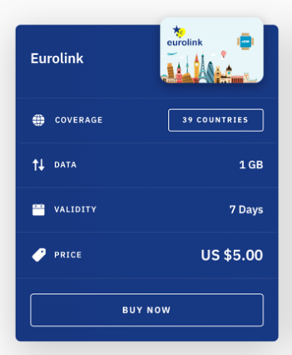

**Freighting of Uniforms Home**

We have been looking recently at ways in which choristers’ uniforms might be brought back to NZ at the end of the tour. Asking one kind soul to carry some 5 or 6 extra uniforms in their suitcase is one option, but that’s very burdensome.

I also looked at freighting with DHL, but they wanted €255 for a 10 kg Cabin-bag sized suitcase. That’s way too expensive.

Unless anyone has a better suggestion, I think we’ll be asking choristers to simply to carry their uniforms on with them if continuing travelling after the Tour.

**Google Maps Offline**

You may not be aware, but it’s possible to use Google Maps offline by doing a Download. It’s a cute little trick which actually works. Here are the instructions:

Open Google Maps.

Tap the Profile icon. (That’s the blue “sad face” at top right).

Select “Offline Maps”.

Tap ”SELECT YOUR OWN MAP”.

Choose whatever area you want.

Tap “Download”.

Close Google Maps.

Next time you open Google Maps your downloaded map will be there – and can be used offline. Do give it a try.

**Returning Into NZ**

A reminder to those returning directly to NZ after the Tour ends will be on Singapore Airlines SQ 281 which arrives Auckland at 10.25pm in the evening of Wednesday 26TH June 2024. You will need to arrange overnight accommodation in Auckland and should be checking your onward domestic flights the next day.

NZ Immigration is moving to digital Arrival Cards, but they are still also using hard copy versions. More on that later.

**Lastly, COVID**

I’m sure we are all only too well aware that Covid continues to circulate out there in the community. Please do everything you can to stay well over the next 20 days.

Apologies this Newsletter has turned into a sequel to “War and Peace”.

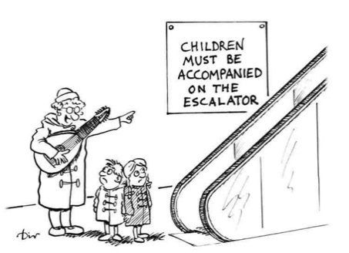

Kind regards

**Ian Gabites**

**Tour Convenor – New Zealand Male Choir**

**Tel: 06 753 2989 Mob: 021209 3787**

**Email: iandjgabites@xtra.co.nz**